
Grade: /
1
5

AI/ML Capstone Project

D2 – Project Design Document (15% of final mark)

Due: Week 5 (softcopy on SLATE, hardcopy to your Professor in class)

Name 1: ______________________________ | Student Number 1: ___________________________
Name 2: ______________________________ | Student Number 2: ___________________________
Name 3: ______________________________ | Student Number 3: ___________________________
Name 4: ______________________________ | Student Number 4: ___________________________
Name 5: ______________________________ | Student Number 5: ___________________________


Instructions:

- Please work on the following deliverable with your group.
- Prepare your deliverable report as discussed in class.
- Type your report using word processing software (preferably using LaTeX, otherwise MS Word is fine).
- Upload your report in PDF format on SLATE. Team leader should upload this deliverable on SLATE as a single PDF file.
- Present a printout (stappled) of your deliverable to your Professor in class in Week 5.

Overall Objectives:

In this “D2 – Project Design Document”, the objective is to design a realistic and achievable project plan that defines technical architecture, milestones, and team deliverables using industry-standard practices. This document will serve as a foundational blueprint for all subsequent development phases, and it must be structured with clarity and professionalism.

Q1
:
Project Objectives

Create a Work Breakdown Structure (WBS) detailing technical tasks and deliverables. As part of your WBS, you will need to include at least four Work Packages (WPs). These WPs should address the major objectives of the AI/ML system architecture and data flow you intend to work on in this capstone project. In the space below, provide an explicit heading for each WP followed by a brief description detailing what exactly you want to accomplish (in 4-6 sentences). [2 marks]


Q2: Project Tasks

The focus here is on identifying the granularity of the WPs. For each WP, develop at least 3-4 tasks detailing the various subcomponents related to the AI/ML pipeline and applications. In the space below, provide a descriptive heading for each task. Then, for each labelled task, provide an explanation of what the task entails (in 1-2 sentences). Avoid being too redundant to what you indicated in Q1. [2 marks]


Q3: Task Owners

Assign roles and responsibilities for each team member. In other words, assign a “task owner” for each task within the WPs. This must be done strategically based on qualifications and interest of the team member being assigned a task. Common roles include, project manager, data engineer, AI/ML engineer, MLOps engineer, etc. Divide the workload equally among the team members so that it is fair, balanced, and realistic. In the space below, list the tasks from Q2, and indicate the name of the team member that will work on the specific task in parenthesis. Also, provide a specific description (in 1-2 sentences) why this specific team member is appropriate to work on the assigned task. [1 mark]


Q4: WBS Diagram

Using the descriptions in Q1 (work packages), Q2 (tasks), and Q3 (task owner) organize your WBS to visually capture relevant information by way of a tree diagram. Your diagram should show the hierarchical relationships among all WPs, tasks, and it should include all relevant sub-branches. Also, make your diagram complete and coherent by enumerating the topics and by placing arrows to show all interconnected associations. Your diagram should visually display an overall summary for the workflow for your AI/ML project. You may
use specialized software to make your diagram (e.g., Visio, draw.io, photoshop, etc.) [1 mark]


Q5: Weekly Milestones

Define weekly milestones and deliverables for project tracking. Your weekly milestones plan should cover Week 5 to Week 14 of the semester. Each week, you will need to complete a certain aspect of your project work (e.g., data gathering/cleaning, AI/ML modeling, model optimization, testing/prototyping, deployment/UI, tech. report writing, final presentation/demonstration). In the space below, enumerate the weeks from Week 5 to Week 14, and provide a bulleted list of the tasks and sub-tasks that you and your group aim to realistically accomplish by the end of each week. [2 marks]


Q6: Gantt Chart

Using the results in Q4 (WBS diagram) and Q5 (weekly milestones), develop a detailed Gantt chart. The Gantt chart is a project management tool that visually illustrates a project schedule over time. Your Gantt chart should display a list of WPs/tasks vertically while being mapped to specific task owners. A timeline is shown horizontally using “horizontal bars” should be used to represent the needed duration in weeks. Make your Gantt chart as detailed as possible. Also, important AI/ML milestones should explicitly be indicted on your Gantt chart. An example of a Gantt chart that you can replicate is show in Appendix A. [2 marks]


Q7: Version Control

Establish version control practices and repository management protocols with Git/GitHub. This tool will allow you to track changes in source code and related files over the span of your AI/ML capstone project. This tool will also allow you to practically collaborate with team members without overwriting each other’s work. In the space below, explain how you intend to use Git/GitHub for version control and for repository planning. Also describe in full detail the collaboration workflow and the strategy that you aim to apply. [1 mark]


Q8: Limitations, Constraints, and Risks

Identify potential limitations, constraints, and risks that you may face during this AI/ML capstone project. As you work on this question, please keep in mind that financial support from Sheridan to teams is not available, and that access this term to GPU-supported labs or clusters is not guaranteed. In the space below, develop a risk mitigation table that highlight the top 5-7 risks that you many encounter as you work on this project. Your table should also include a contingency plan for each risk. The contingency should propose a backup strategy to mitigate the potential risk, to avoid disruptions to the operations of your workflow, and to allow you to complete your AI/ML project. In the table below, provide a heading for each cell of the table that summarizes the risk and the related contingency. Then, provide a description for each cell of the table (in 2-3 sentences). [2 marks]

  No. | Limitations, Constraints, Risks |   Contingency Plan
  #1 |  | 
  #2 |  | 
  #3 |  | 
  #4 |  | 
  #5 |  | 
  #6 |  | 
  #7 |  | 

Q9: Project Outcomes

By Week 14, all teams must prepare: (i) D4, a formal technical report detailing the comprehensive work on the AI/ML capstone project, (ii) D5a, slide presentation of the technical report, and (iii) D5b, a working live demonstration of the AI/ML solution.

Q9.1 – What do you anticipate the major outcomes of your capstone project will be?

Q9.2 – What type of AI/ML method will your solution consider (i.e., regression, classification, clustering, or possibly a combination of different methods)?

Q9.3 – What type of UI/system will you have to showcase a working demonstration of your AI/ML solution (e.g., MobileApp, cloud service, locally/publicly hosted URL, AI-powered physical system – IoT, drone, or robot, or possibly a combination of various UI/systems)?

In the space below, provide specific answers to these three questions to demonstrate that your anticipated capstone results are thoroughly considered and strategically planned. [2 marks]

Page
References (Include 12-15 peer-reviewed sources to back your AI/ML capstone project ideas cited above with your answers. You may reuse references from “D1 – Project Proposal”).

- ?

- ?

- ?

- ?

- ?

- ?

- ?

- ?

- ?

- ?

- ?

- ?

Appendix A: Example of “Gantt Chart”

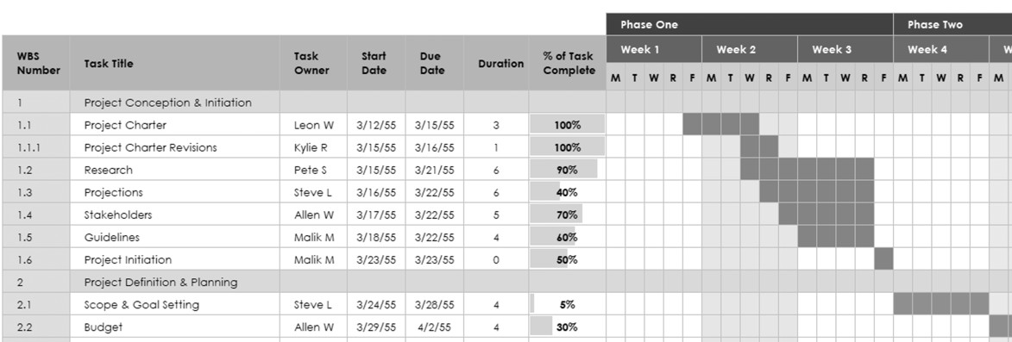

Good Luck!
Page

